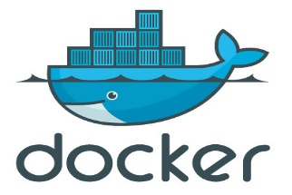

[This Photo](https://www.flickr.com/photos/xmodulo/14098888813) by Unknown Author is licensed under [CC BY](https://creativecommons.org/licenses/by/3.0/)

**List of Docker Commands**

1. docker --version: To check the version of docker

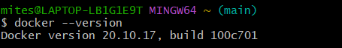

1. docker run nginx: It will run container named “nginx”.

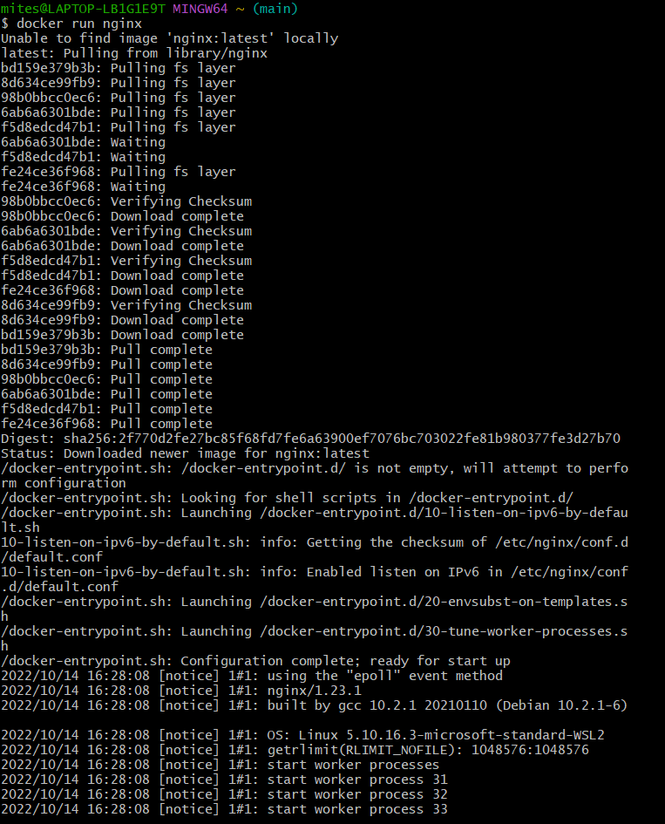

1. docker ps: It will list all the running containers.



1. docker ps -a: It will list all the running and exited containers.



1. docker stop docker-tutorial : It will stop the container named “docker-tutorial”.



1. docker rm docker-tutorial: To remove a particular container, it should be in stop mode. And then, one can remove the stopped container. This command will remove the container named “docker-tutorial”.



1. docker images: This command gives us the list of images.

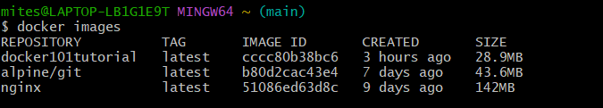

1. docker rmi docker101tutorial: This command will remove the image named “docker101tutorial”.

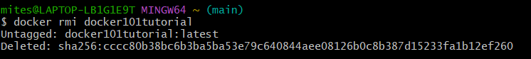

1. docker pull debian: It will pull the image named “debian” from dockerhub. It will not run it.

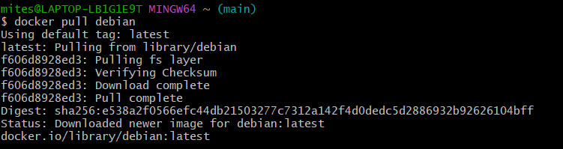

1. docker run debian sleep 5: It will run the container named “debian” for 5 seconds and thereafter exit it.

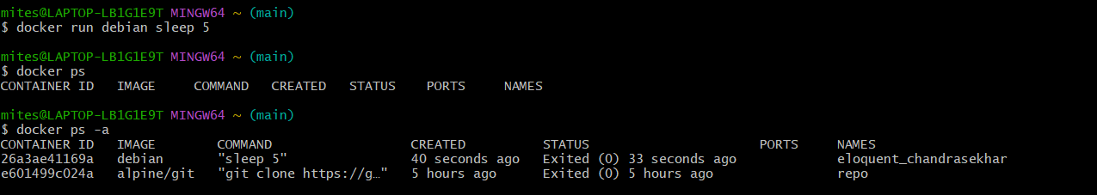

1. docker --help: To know definition of different commands.

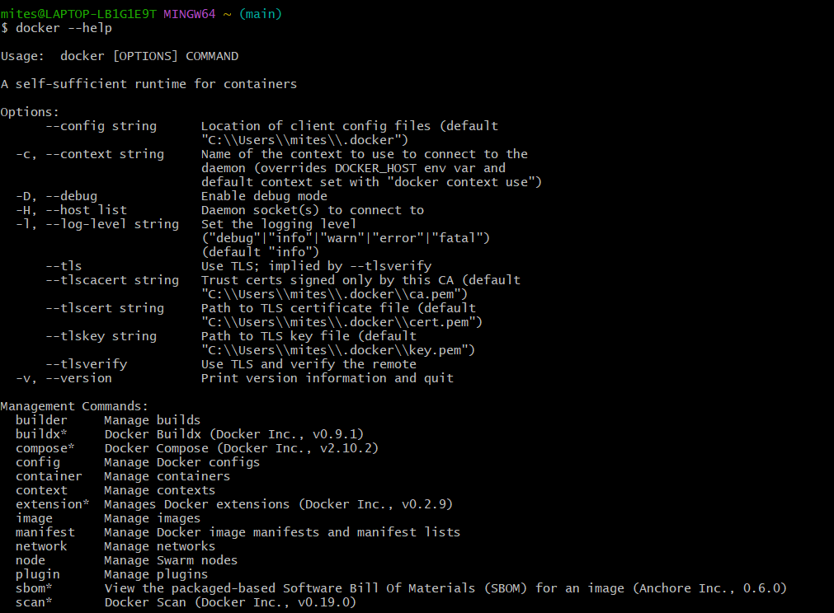

1. docker run -d -p 80:80 docker/getting-started: It will run the “getting-started” container. -d means detached mode (in the background it will keep running), -p is assigning the port. First 80 is the host port number and other 80 is the container port number. We can also change the port number.

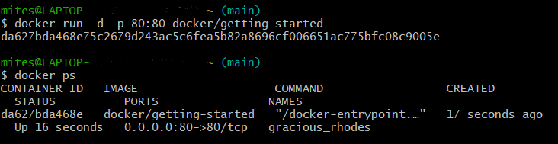

1. docker build -t welcome-app . : This command will build the image named “welcome-app”.

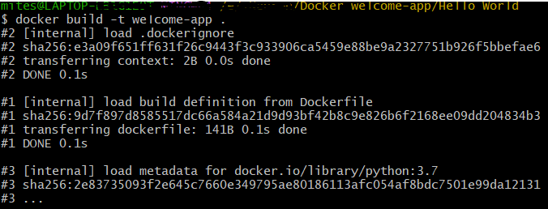

1. docker rmi -f welcome-app : Will remove the image forcefully
2. docker push miteshpawanarkar/welcome-app:latest : This command will push the tagged image to registry.